**Step 1 & 2**

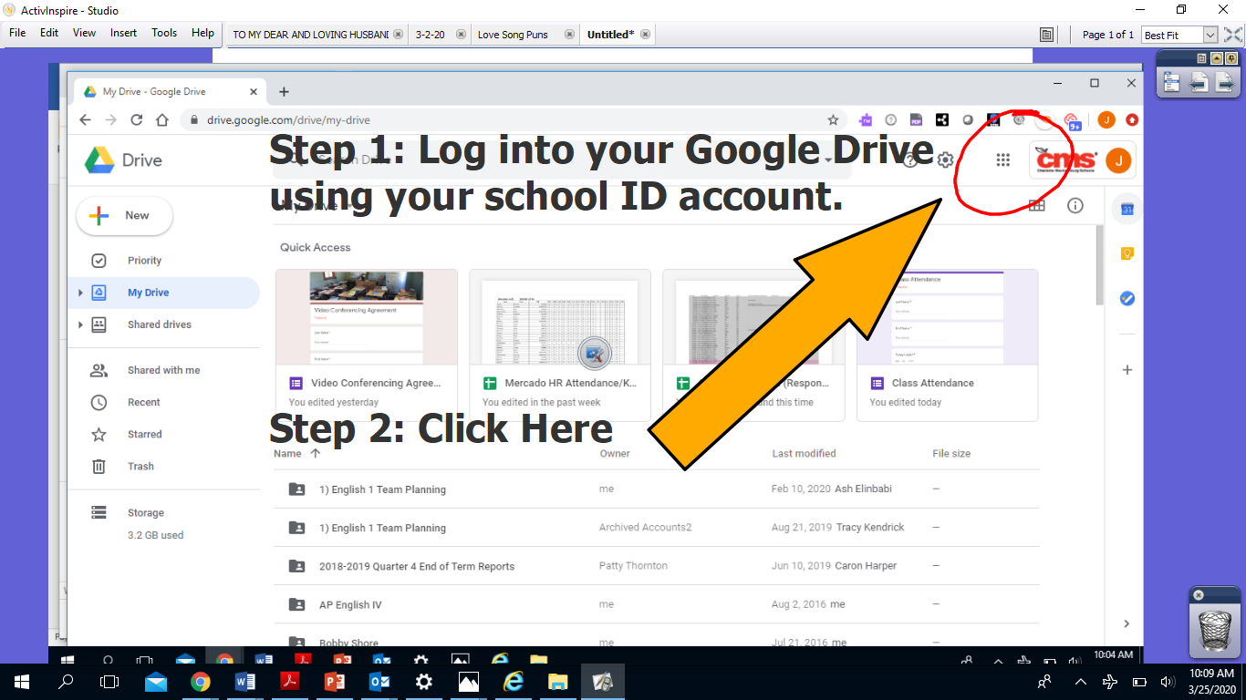

**Step 3: Click “Meet.”**

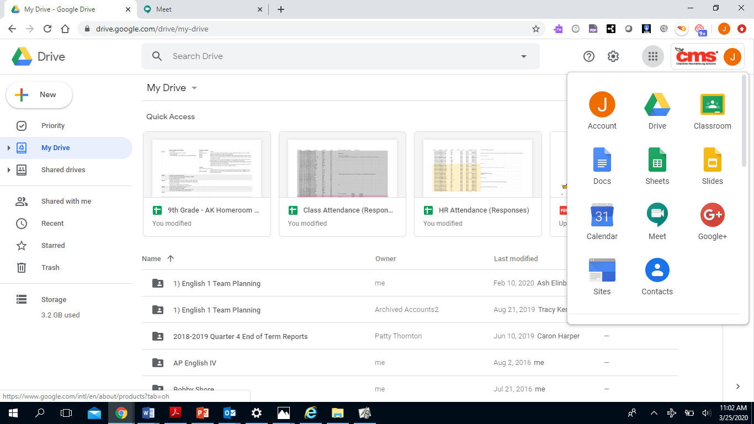

**Step 4**

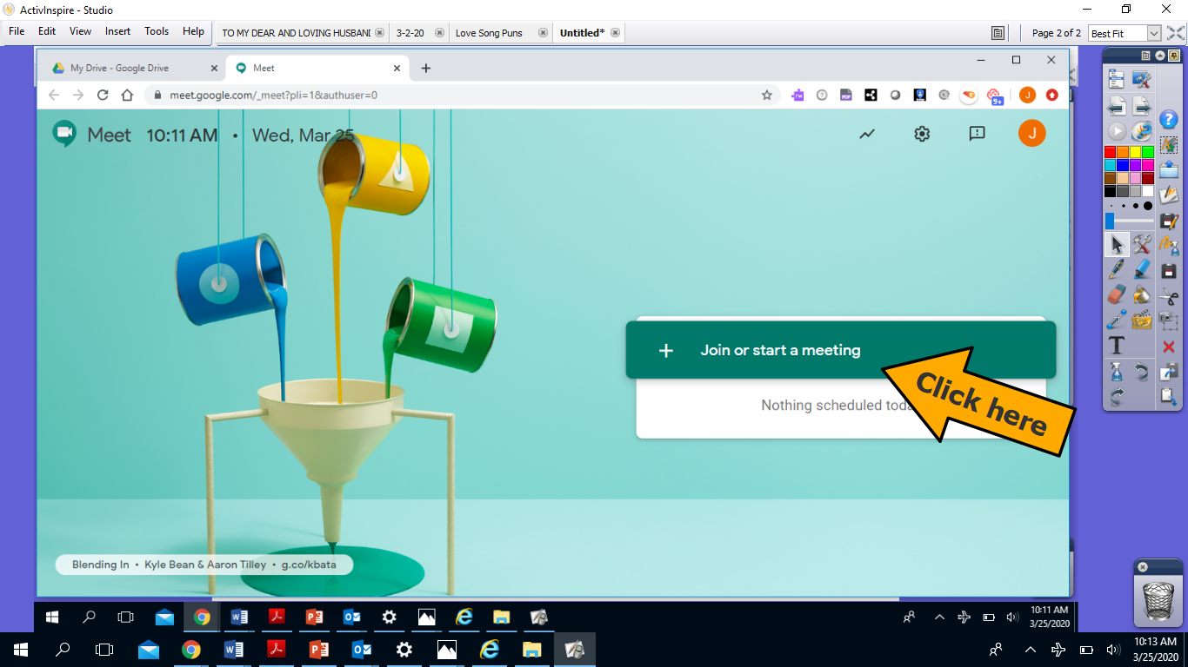

**Step 5: Enter Password and then click CONTINUE.**

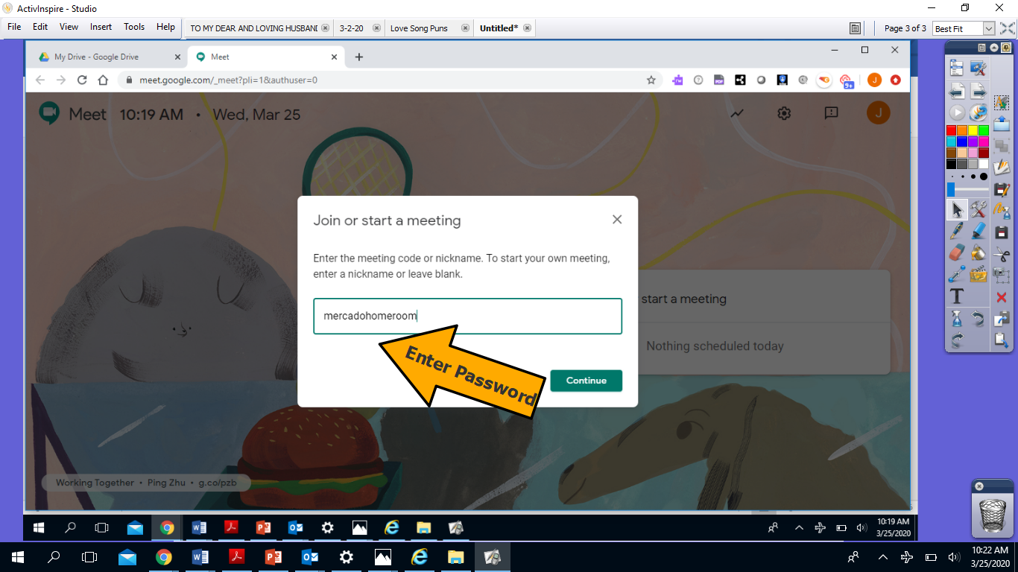

**Step 5: Meeting preparations**

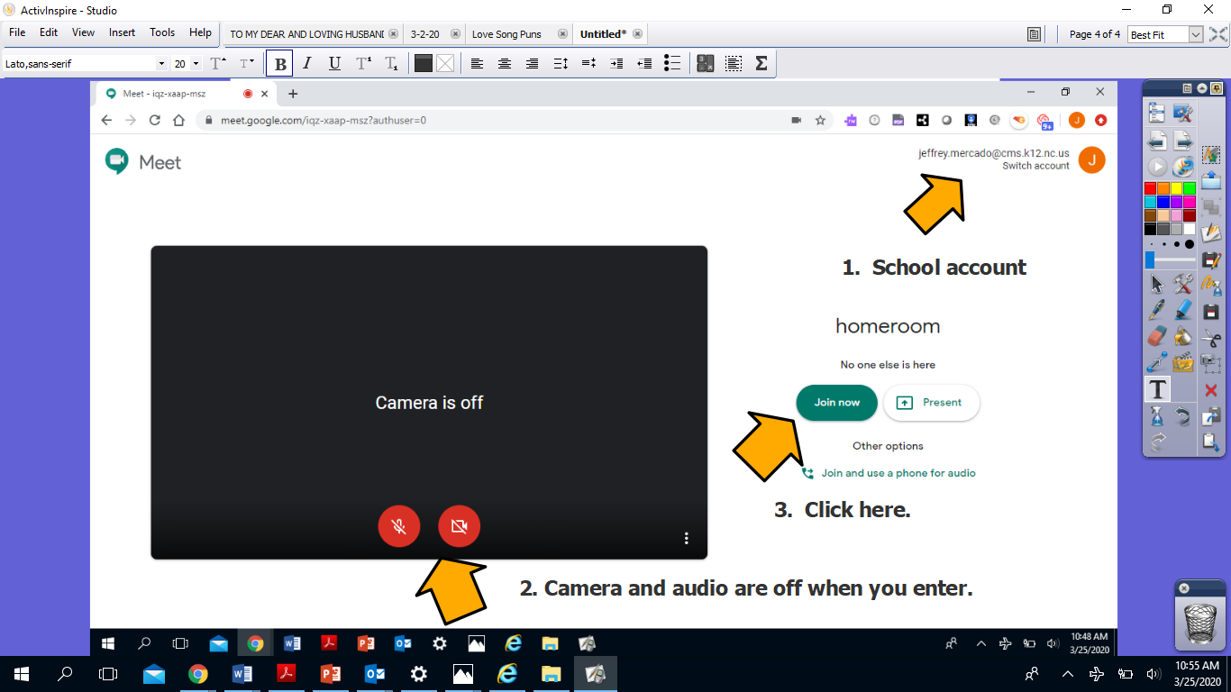

**You’ll be in the meeting then!**